RESOLUTION NO.__________

RE: CERTIFICATE OF APPROPRIATENESS UNDER THE
PROVISIONS OF THE ACT OF THE PENNSYLVANIA
LEGISLATURE 1961, JUNE 13, P.L. 282 (53
SECTION 8004) AND BETHLEHEM ORDINANCE NO.
3952 AS AMENDED.

WHEREAS, it is proposed to install signs to replace the existing signs at 7 E 3rd St.

NOW, THEREFORE, BE IT RESOLVED by the Council of the City of Bethlehem that a Certificate of Appropriateness is hereby granted for the work.

Sponsored by: (s)

(s)

ADOPTED BY COUNCIL THIS DAY OF

(s)
President of Council

ATTEST:

(s)
City Clerk

HISTORIC CONSERVATION COMMISSION

CASE # 618– It is proposed to install signs to replace the existing signs at 7 E 3rd St.
OWNER/APPLICANT: Shale Road LP/ Joshua Ross

The Commission upon motion by Mr. Evans seconded by Mr. Traupman adopted the proposal that City Council issue a Certificate of Appropriateness for the proposed work described herein:

- The proposal to install signs to replace the existing signs at 7 E 3rd St was represented by Joshua Ross.

- The new or refaced wall sign will be 29” high x 8’ wide.

- The sign will read “Raygun Samurai Tattoo” in yellow outlined lettering infilled with red on a white background with black border, circle and “gun”.

- The new or refaced projecting sign will be 4’ high x 3’ wide.

- The sign will read the same as the wall sign and have black lettering outlined in blue on a white background with a red samurai graphic.

- If the signs are replaced they will match the old signs in size. The projecting sign will hang from the existing black scroll bracket.

- A 15” – 18” wide door sign in white vinyl will also be installed.

- The sign will have the samurai logo and hours of operation.

- The motion to approve the proposal was unanimously approved.

CU: cu

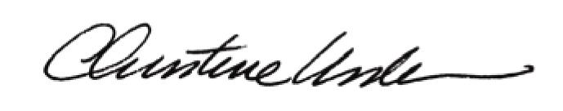
By:

Date of Meeting: July 17, 2017 Title: Historic Officer

